SOFTWARE REQUIREMENTS SPECIFICATION
For
Idle-to-Income: A Local Car Rental Platform

Prepared by:

Angelo Dela Torre
Glowen Tanaman
Danryl James B. Usa

Submitted in fulfillment requirements for Integrative Programming and Technologies 2 (IT305)

December 7, 2025
- Introduction

  - Purpose

The purpose of this system is to provide a community-based vehicle rental platform where vehicle owners can list and rent out their cars when not in use. This system benefits both sides: owners can earn additional income from idle vehicles, while renters gain access to affordable and flexible transportation without the need to own a car.

Intended Audience

This document is intended for:

• Vehicle Owners – individuals who will register and list their vehicles for rent.
• Renters – individuals who will browse, book, and rent vehicles as needed.
• Secondary Users – System administrators and support staff responsible for ensuring smooth operation, verifying users, and maintaining trust.

1.3 Product Scope
The Local Car Rental System will serve as a peer-to-peer platform for renting cars.
The service is limited to the local community/geographical area specified during deployment. Users can register as either owners or renters, manage bookings, handle payments securely, and provide feedback. The responsibility in compensation for specified loss and damage for the car will be given to the renter.

1.4 Definitions, Acronyms, and Abbreviations

    - P2P – Peer-to-Peer
    - UI – User Interface
    - DBMS – Database Management System
    - Owner – A user who lists their vehicle for rent
    - Renter – A user who books and pays for a vehicle rental

Overall Description

  - User Characteristics

    - Car Owner: Individuals with available vehicles, may have basic to moderate computer literacy, and must provide vehicle details, availability schedules, and identification for verification.
    - Car Renter: Users with varying levels of technical experience who require easy access to book vehicles.
    - System Administrators: Tech-savvy personnel who oversee transactions, manage users, and ensure system security.

2.2 Constraints

    - Requires stable internet connection for online transactions.
    - Legal compliance with transportation and rental regulations.
    - Payment gateways must be secure and integrated properly.
    - Limited to users with valid accounts and verified credentials.
    - Vehicle insurance, driver’s license validity, and compliance with local transportation laws must be observed.

Assumptions and Dependencies

    - Users have access to smartphones or computers with internet connectivity.
    - Third-party services (payment gateways, map services, email notifications) are available and functional.
    - Users have valid driver’s licenses and adhere to road safety rules.
    - Renters will return vehicles in the same condition as received.
    - Vehicle owners will provide accurate and honest information about their vehicles.
    - The system depends on reliable hosting and database servers.

3. Requirements Specifications

3.1 Functional Requirements
The Idle-to-Income Car Rental Platform provides the following functional requirements:

User Authentication: Allows new users to register an account and existing users to log in using a username, password, and role (renter or owner).
Vehicle Management: Owners can add, edit, and view vehicles including details such as name, type, rate, hours of availability, and location.
Vehicle Browsing: Renters can browse a list of available vehicles and view details for each.
Booking Process: Renters can book vehicles directly through the system interface.
Messaging System: Renters can send messages to vehicle owners for inquiries; owners can respond to renters in real-time within the platform.
Role-Based Dashboards: Different interfaces are provided for renters and owners to ensure relevant functionality and data visibility.
Logout Functionality: Allows users to securely exit their session.

3.2 Non-Functional Requirements
Usability: The system should provide a clean, intuitive user interface optimized for ease of use by both renters and owners.
Reliability: The platform must ensure consistent access to vehicle data, bookings, and messages without frequent crashes.
Performance: The system should respond to user actions (login, vehicle browsing, messaging) within 2 seconds on standard internet connections.
Security: User credentials and session data must be securely handled, preventing unauthorized access.
Scalability: The platform should be able to accommodate growing numbers of users and vehicles without performance degradation.
Portability: The system must run on major browsers (Chrome, Firefox, Edge) and adapt to different screen sizes via responsive design.
3.3 External Interface Requirements
User Interface: The platform provides web-based screens including signup, login, dashboards, and modal windows for vehicle and messaging.
Hardware Interface: Requires any standard device with internet access such as desktops, laptops, tablets, or smartphones.
Software Interface: Compatible with standard modern browsers and does not require additional plugins.
Communication Interface: The system utilizes web-based communication protocols (HTTP/HTTPS) for client-server interactions.
3.4 System Models
The following diagrams illustrate the functionality and flow of the system:

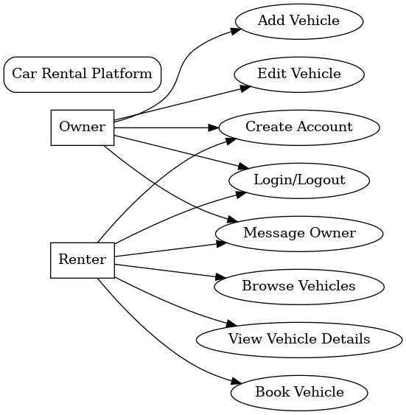
Use Case Diagram

Process Flow Diagram

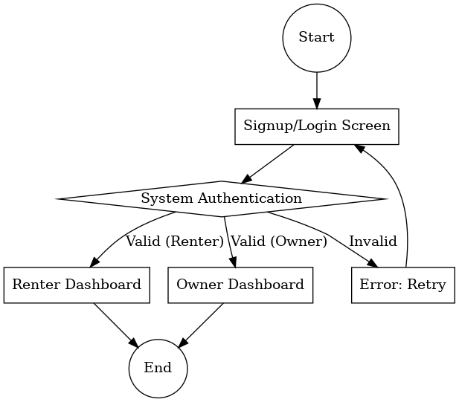

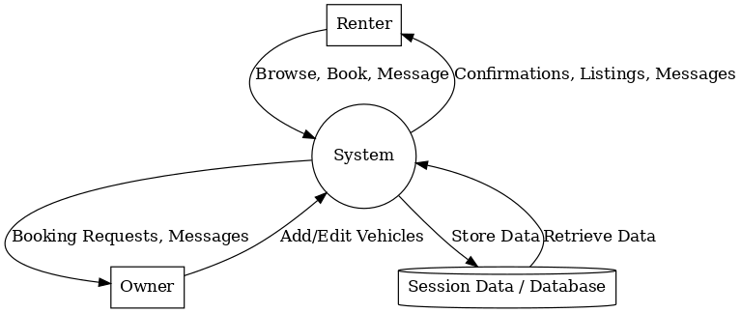
Data Flow Diagram

Entity Relationship Diagram
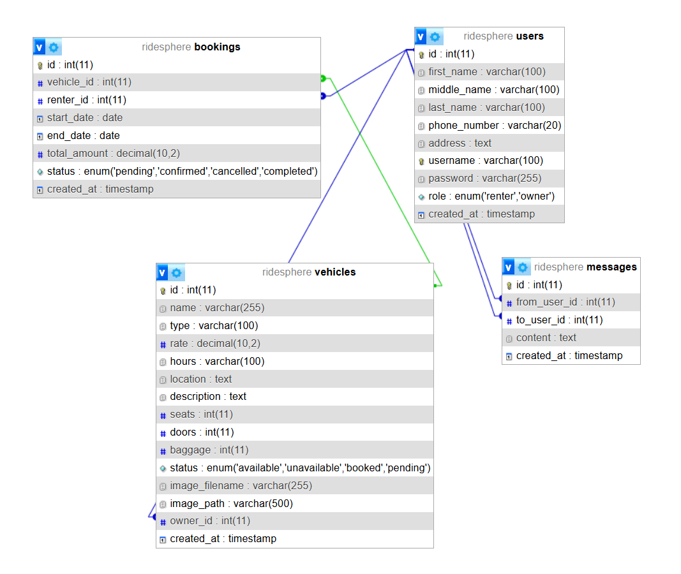

3.6 Implementation

The implementation phase involves the actual development of the Car Rental System, transforming the design and database plans into a fully functional web application. The system was implemented using PHP as the main backend language, integrated with MySQL for database management. It focuses on providing core functionalities such as vehicle registration, image uploading, booking management, and secure user interactions between renters and owners through a responsive interface.

Development Environment

Backend Framework / Technology:

  - Core PHP with PDO (PHP Data Objects) – used for establishing secure and efficient communication with the MySQL database. The backend handles all major operations such as adding, updating, retrieving, and deleting vehicle data. It also manages file uploads for vehicle images, JSON-based responses for the frontend, and validation of user inputs.
  - RESTful API Architecture – implemented to allow smooth interaction between the frontend and backend using AJAX requests and JSON responses.
Frontend:
  - HTML5, CSS3, JavaScript – used to design a clean and interactive interface for users and administrators.
  - Bootstrap / Tailwind CSS – ensures that the system remains responsive across different screen sizes and devices.
  - AJAX (Asynchronous JavaScript and XML) – allows real-time data exchange with the backend without reloading the page, improving system responsiveness and user experience.

Database:
MySQL – serves as the central storage for all data, including user accounts, vehicle records, and booking details. The database structure ensures referential integrity and supports relational queries for smooth data retrieval.

Other Tools and Utilities:
XAMPP – provides a local server environment for PHP and MySQL development.
phpMyAdmin – used for managing and inspecting the database structure.
Git and GitHub – employed for version control and tracking changes during development.
JSON Encoding/Decoding – used for sending and receiving structured data between the client and server.

The system’s implementation emphasizes modularity, data security, and ease of maintenance. Each PHP function is structured to handle a specific task—such as adding vehicles, updating records, or managing uploads—making the backend efficient and scalable for future enhancements.

